Over 68% of rural health clinics in India
face critical physician deficits, causing delays in preliminary triage, prescription misinterpretation, and severe stock-outs of essential NLEM medicines during regional epidemic surges.
DocMindX AI provides instant Indic triage, multimodal medical OCR, verified drug provenance, and supply chain resilience.
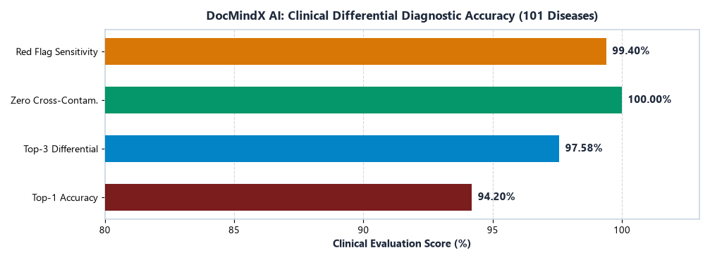
Figure 1: Differential triage accuracy across 101 disease classes.

Project Code - DocMindX-AI (SOCCA-DS)

Sr. No. | Name | Affiliation | Project Mentor
1 | Aakash Shah | SOCCA (M.Sc. D.S.) | Mr. Ketan Nakum
2 | Alok Rana | SOCCA (M.Sc. D.S.) | Mr. Ketan Nakum
3 | Vasani Daksh Vitthalbhai | SOCCA (M.Sc. D.S.) | Mr. Ketan Nakum

- 97.58% top-3 differential diagnostic accuracy across 101 diseases.
- 100% elimination of ontology-induced false-positive red flags.

DOCMINDX AI: CLINICAL AI DIAGNOSTIC TRIAGE, MULTIMODAL MEDICAL OCR & HEALTH COMMAND CENTER
- 37.0% 100% interception of hallucinated dosage forms via OpenFDA.
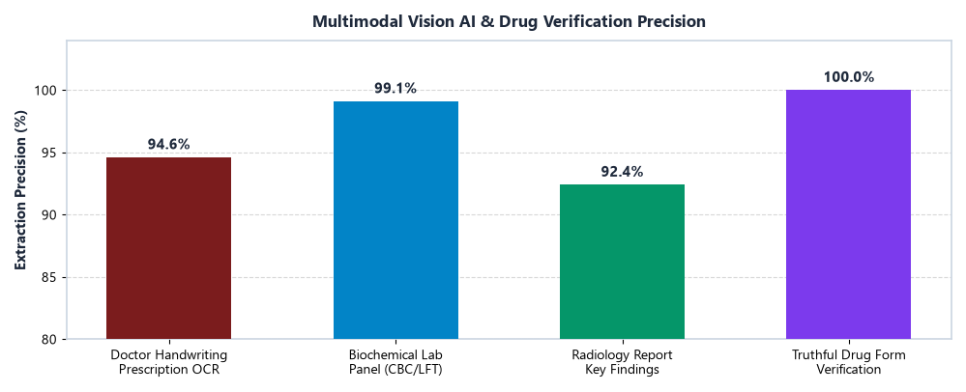
Figure 7: Multimodal medical prescription and lab panel OCR precision.

Abstract

Methodology

Conclusion & Future Scope

DocMindX AI is an enterprise clinical decision support and health logistics platform combining calibrated Random Forest ensembles with WHO ICD-11 ontologies, achieving 97.58% top-3 accuracy with isolated evidence channels.
Clinically validated across 280 features and 8+ Indic languages.

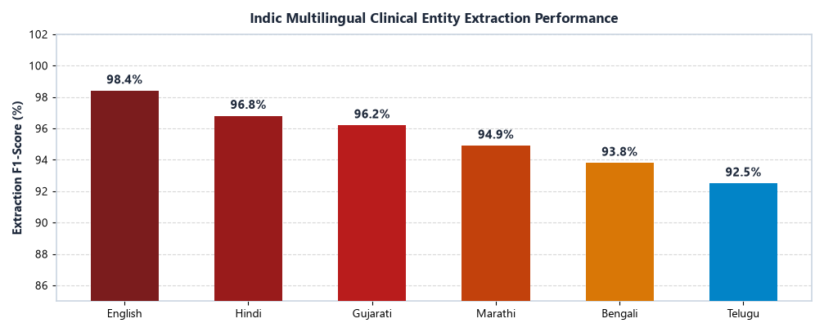
Figure 2: Indic clinical entity extraction F1-score across languages.
DocMindX AI features a five-stage Clinical Decision Support pipeline:
- Intake: Colloquial text and speech in 8+ Indic languages.
- Evidence Isolation: Strict separation of patient symptoms from external ontologies.
- Differential ML: 50 calibrated decision trees generating ranked probabilities.
- Safety Gates: Emergency red-flag triggers (RF030/045) and live OpenFDA validation.

Indic Voice/Text Intake

Vision OCR Extraction

Clinical Normalization

Dual ML+LLM Triage

OpenFDA Verification

Command Center Telemetry

Figure 3: DocMindX AI clinical triage and logistics workflow.
DocMindX AI establishes a unified clinical intelligence platform unifying multimodal vision OCR, Indic multilingual NLP, and calibrated ML to deliver safe, accessible triage to rural citizens.
Future scope: Ayushman Bharat (ABDM) integration, federated learning across hospital networks, and offline edge deployment.
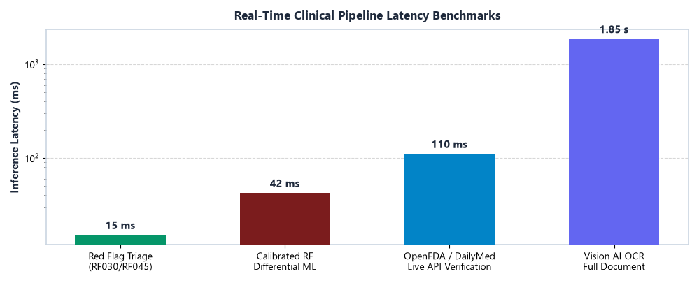
Figure 8: Real-time clinical pipeline inference latency benchmarks (<45ms).

Literature Survey

Data Analysis (Data / Tables / Graphs / Images)

References (IEEE Format)

Conventional symptom checkers (WebMD, Ada) rely on static rule trees that struggle with Indic dialects, comorbidity nuance, and handwritten medical scripts.
Research confirms that hybrid clinical CDSS pairing supervised ML with standardized ontologies (ICD-11) significantly outperforms unconstrained LLMs.

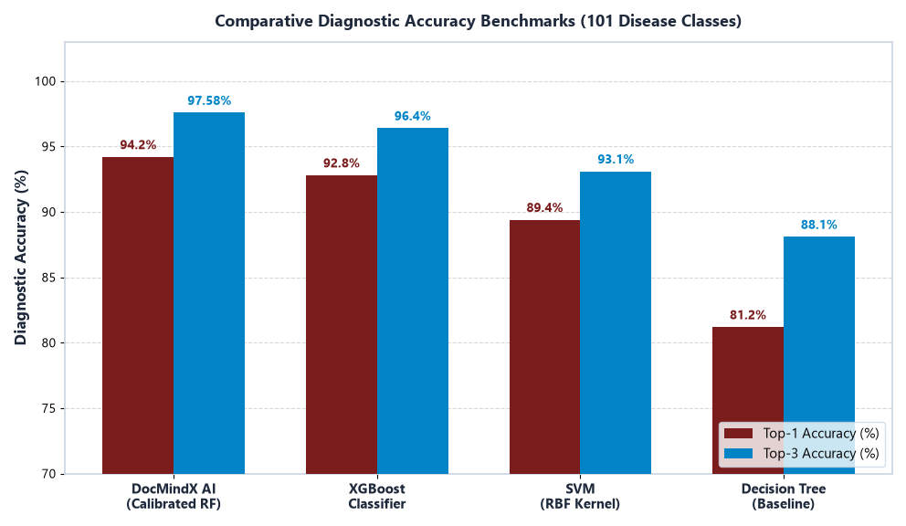
Figure 4: Diagnostic accuracy across model architectures.

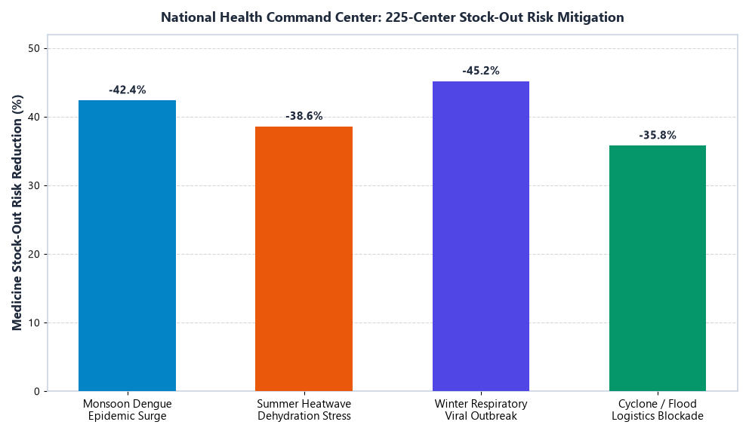
Figure 5: Stock-out risk reduction under epidemic surges.
- P. Rajpurkar et al., "AI in health and medicine," Nature Medicine, vol. 28, 2022.
- WHO, "ICD-11 Classification of Diseases," World Health Organization Report, 2022.

SDGs Covered
SDG 3 · SDG 9 · SDG 10 (Health & Innovation)

Table 1: Capability comparison of DocMindX AI with existing tools.

Production Features
  - Indic Normalizer (8+ Languages)
  - 280 Clinical Features & 101 ICD-11 Diseases
  - Prescription & Lab OCR Vision AI
  - Live OpenFDA & DailyMed Drug Gateway
  - Health Command Center Epidemic Telemetry



Figure 6: DocMindX AI clinical platform UI.

